
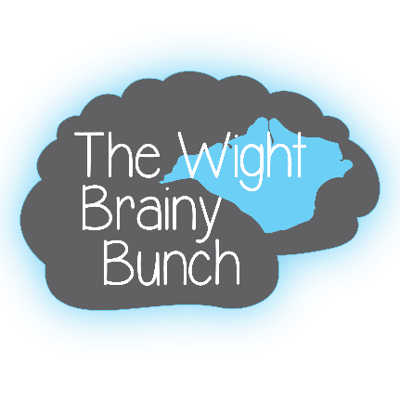
RACE NIGHT
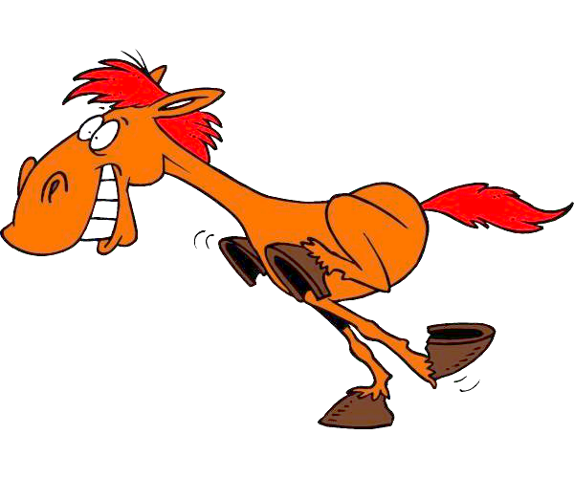


NORTHWOOD CRICKET CLUB
20:00HRS
3RD NOVEMBER 2018
ALL PROFITS WILL BE DONATED TO THE WIGHT BRAINY BUNCH TO SUPPORT ISLE OF WIGHT FAMILIES AFFECTED BY BRAIN TUMOURS.

